

**DSC 640 Data Presentation & Visualization**

[**T302 Winter 2022 (2233-1)**](https://cyberactive.bellevue.edu/webapps/blackboard/execute/courseMain?course_id=_514818_1)

**Milestone 2.3 Project Task 1: Dashboard**

**Anuj Tanwar**

**Table of Contents**

Design Choices 3

Main Dataset 3

Supplemental Dataset 3

Dashboard 3

Donut Chart 4

Line Chart – Fatalities by Year 4

Bar Chart – Air Traffic by Year 4

Line Chart – Passenger & Revenue 4

Horizontal Bar chart – Fatalities by Each Airline 4

Horizontal bar chart - Available Seat KM Flown Every Week (Billions) by Airline 4

References 5

### Design Choices

I chose power BI as the tool to create dashboard for DSC 640 project visualizations. I have used color palette from venngage.com and avoided colors as per suggestion.

### Main Dataset

1. [Airline Safety](https://github.com/fivethirtyeight/data/tree/master/airline-safety), Aviation Safety Network - airline-safety.csv downloaded from Github.
2. [Accidents and Fatalities Per Year](https://docs.google.com/spreadsheets/d/1SDp7p1y6m7N5xD5_fpOkYOrJvd68V7iy6etXy2cetb8/edit#gid=1448957446), Accident and fatalities data as provided in project task.

### Supplemental Dataset

1. [Death Rate per Year](https://www.baaa-acro.com/statistics/death-rate-per-year?page=1) (aircraft) downloaded from Bureau of Aircraft Accidents.
2. [Passengers transported](https://www.transtats.bts.gov/Data_Elements.aspx?Qn6n=F) per year downloaded from Bureau of Transportation Statistics.

Downloaded the data excel and filter total yearly number of passengers before saving the file. This was to avoid the multiple rows for each year which made it easier to create visualizations in Power BI.

1. [Airlines Operating Revenue](https://www.transtats.bts.gov/Data_Elements_Financial.aspx?Qn6n=K) (In Thousands of Dollars) from Bureau of Transportation Statistics.

Downloaded the data excel and filter total yearly revenue per year before saving the file. This was to avoid the multiple rows for each year which made it easier to create visualizations in Power BI.

### Dashboard

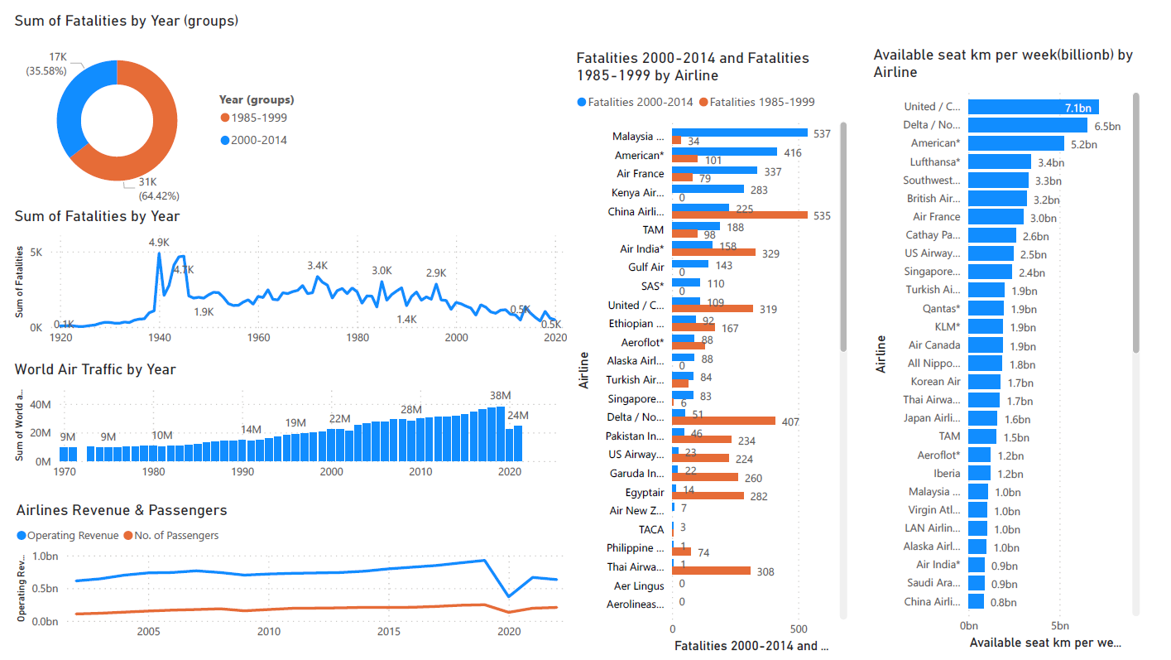

### Donut Chart

I have divided the period between two groups, 1985-1999 and 2000-2014, and then compared the Air Traffic Fatalities between them. This shows, how fatalities have reduced almost to half during 2000-2014 as compared to 1985-1999. Hence, showing how the air traffic has become more safer over the period of time.

### Line Chart – Fatalities by Year

This chart shows total Number of Fatalities from 1920 to 2020. From the plot it is evident how Air Fatalities have reduced from 5k in 1940 to 0.5k in 2020. I have created a filter to filter out years between 1920 and 2020 as there is insignificantly less data for rest of the years.

### Bar Chart – Air Traffic by Year

This chart shows total air traffic from 1970 to 2020. From the plot it is evident how Air Fatalities have reduced significantly in last 50 years. From above line chart and this bar chart, it is evident that Fatalities have reduced when air traffic has increased multiple folds over the period of time which in term depicts that air traffic has become safer.

### Line Chart – Passenger & Revenue

This chart is showing the Passenger count as well as Revenue as two different lines over the same period range. This shows how the passengers and revenues have shown to grow over the period and air travel has become more and more popular.

### Horizontal Bar chart – Fatalities by Each Airline

* 1. Comparison of Total Fatalities by group of years, 1985-1999 and 2000-2014, for each Airline.

Chose bar chart because it shows best comparison between two groups for each airline. For example, Malaysian Airlines had more fatalities between 2000-2014 as compared to 1985-1999.

### Horizontal bar chart - Available Seat KM Flown Every Week (Billions) by Airline

This bar chat shows the sheer volume airlines experienced on a weekly basis.

Comparing data from both the above Horizontal bar charts, let’s say for United Airlines, shows that it has flow over 7 billion Kms in a week and had only 109 fatalities in 15 years (2000-2014). This clearly shows air transportation is pretty safe.

### References

**Data References:**

*Death Rate per Year* Retrieved from Bureau of Aircraft Accidents Archives: <http://www.baaa-acro.com/statistics/death-rate-per-year?page=0>

*Airline Safety*. Retrieved from Github - fivethirtyeight: <https://github.com/fivethirtyeight/data/tree/master/airline-safety>

*Operating Revenue (In Thousands of Dollars)* Retrieved from Bureau of Transportation Statistics: <https://www.transtats.bts.gov/Data_Elements_Financial.aspx?Data=7>

*Passengers All U.S. Carriers - All Airports*. Retrieved from Bureau of Transportation Statistics: <https://www.transtats.bts.gov/Data_Elements.aspx?Data=1>

**Color Palette Reference:**

*How to Use Color Blind Friendly Palettes to Make Your Charts Accessible*. Retrieved from Venngage: <https://venngage.com/blog/color-blind-friendly-palette/#3>